How to Build a computer

CPSC 311- 04

Nicholas Ayson

2021

**Table of Contents:**

**Introduction**……………………………………………………………………………………………………………………………………. 3

**PC case or tower**……………………………………………………………………………………………………………………………4

Cost……………………………………………………………………………………………………………………………………..4

Sizes………………………………………………………………………………………………………………………………….....4

Cables in case……………………………………………………………………………………………………………………..5

Overall…………………………………………………………………………………………………………………………………4

**Motherboard**………………………………………………………………………………………………………………………………….6

Sizes…………………………………………………………………………………………………………………………………….6

Cost……………………………………………………………………………………………………………………………………..7

Compatibilities with CPU…………………………………………………………………………………………………7

Install into case………………………………………………………………………………………………………………….8

**RAM**……………………………………………………………………………………………………………………………………………....9

RAM size……………………………………………………………………………………………………………………………9

Cost for size……………………………………………………………………………………………………………………….9

Install into motherboard……………………………………………………………………………………………………10

**CPU**………………………………………………………………………………………………………………………………………………..11

Cost/Options………………………………………………………………………………………………………………………11

Install into motherboard……………………………………………………………………………………………………11

**GPU**………………………………………………………………………………………………………………………………………………..12

Cost/Options………………………………………………………………………………………………………………………12

How to connect to motherboard……………………………………………………………………………………….13

Compatibility……………………………………………………………………………………………………………………..14

**SSD/HDD**……………………………………………………………………………………………………………………………………….14

Cost/Options………………………………………………………………………………………………………………………14

How to connect to case and motherboard……………………………………………………………………….15

**Power Supply**……………………………………………………………………………………………………………………………….17

Cost (don’t cheap out) …………………………………………………………………………………………….17

Watts…………………………………………………………………………………………………………………………18

Installation………………………………………………………………………………………………………………..18

**System Cooling**……………………………………………………………………………………………………………………19

Intake vs. Exhaust …………………………………………………………………………………………………..19

Cost..…………………………………………………………………………………………………………………………20

Installation……………………………………………………………………………………………………………….20

**Peripherals**………………………………………………………………………………………………………………………….22

Keyboard Prices………………………………………………………………………………………………………22

Keyboard mechanical vs membrane……………………………………………………………………..22

Mice ………………………………………………………………………………………………………………………..23

Monitor…………………………………………………………………………………………………………………….23

**Overall**…………………………………………………………………………………………………………………………………24

**Sources**…………………………………………………………………………………………………………………………………25

**Introduction**

There are many ways to go about building a PC from scratch. The purpose of this guide is to show the types of parts you will run into during the selection and building process. We will start with the outer part of the computer and eventually move inwards as we continue to assemble the PC. All parts are equally as important to make a computer works properly, but some parts may require greater quality which may cost more money in the long run.

To get started you might want to consider your budget and the purpose of what you are using your PC for. For instance, if you are solely using a computer for business reasons without including space and speed for gaming you may want to consider the lower end of some parts. If you want a computer that can do more gaming and video editing you will have to consider a higher end of PC components. This guide is intended to explore the various parts of a computer, what to consider, and what each part of the PC is designed to do.

Compatibility is a very important part of building a PC because you will need to see what parts will fit with another component. For instance, if a CPU from intel will fit in a motherboard that was intended only for AMD. These compatibility issues are what scare people away from building their own computers, but you can visit these sights to test compatibility for you:

<https://pcpartpicker.com/list/>

<https://www.newegg.com/tools/custom-pc-builder>

These will walk you through which parts you will be allowed to choose based on what items you pick out throughout the process.

*Cautions*

During this process it is very important that you exercise the practice of being always grounded. Being grounded means to protect yourself from static electricity as even the smallest amount can sometimes fry computer components. You could buy anti-static wristbands to prevent this, but in my personal experience if you aren’t building the PC over a carpet or an area with large field of static electricity you should be fine.

**Case or Tower**

The purpose of the case is to allow the user to safely contain the rest of the computer parts in a relatively safe environment. This is mostly to prevent the outside elements from getting into the PC. Dust is one of the worst elements that can harm a computer and a PC case limits the amount of dust from getting in.

*Cost*

The cost of a PC case can vary across many different brands and form factors. However, the range for a good PC case on occasion can be from $85 to $400. There are more expensive cases for higher end computers, but to stay within a reasonable price I would recommend about $100 to $200 would be reasonable.

*Sizes*

The sizes of a case are very important during the building of a PC. There are many form factors to choose from but the most important to take note of are Full tower, Mid Tower, Mini Tower, and small form factors.

A full tower PC case is the safest option for most beginners looking for a PC as it can fit almost anything in it. Full towers can fit any size motherboard and almost all cooling accessories you can throw at it.

A mid tower can fit any standard ATX motherboards and any lower sizes easily. Meaning it is a little smaller than the full tower. The ATX and other types of motherboards will be mentioned again in the next section of the guide

A mini tower can fit both the Mini-ITX and Micro ATX boards. These mini towers are generalized to a smaller custom build meaning that computers can get even smaller.

Finally, there is the small form factor case meant for experienced builders and even prepaid computers built by companies. These cases are meant to take up as little space as possible and only fit specific parts built by specific companies. It is very difficult to build in one of these due to the lack of spaces for different components.

We will move on to the cables introduced inside of the case that are used for turning on the PC and various lighting effects.

*Cables in the case:*

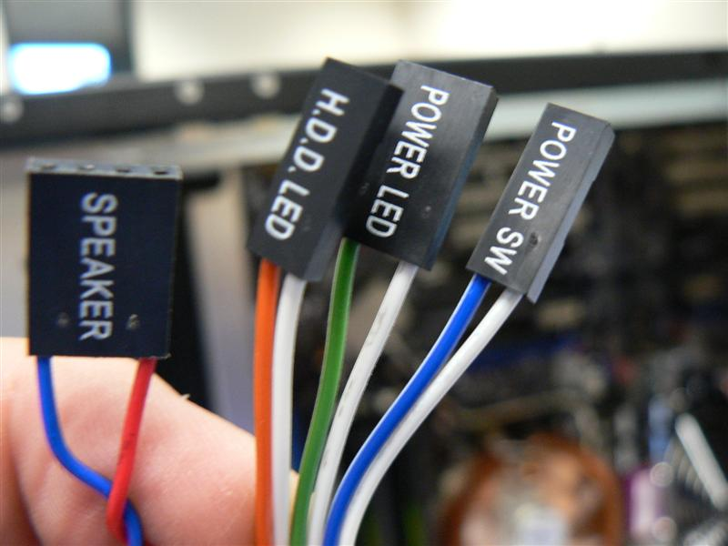

These are the most common switches in a pc case made for the buttons and lighting that come with the tower when you apply the motherboard and power supply. These will be plugged into the motherboard and will follow the chart below. Some of the ports contained in the motherboard will not come with the PC case but you should be able to navigate to which ones match your cables.

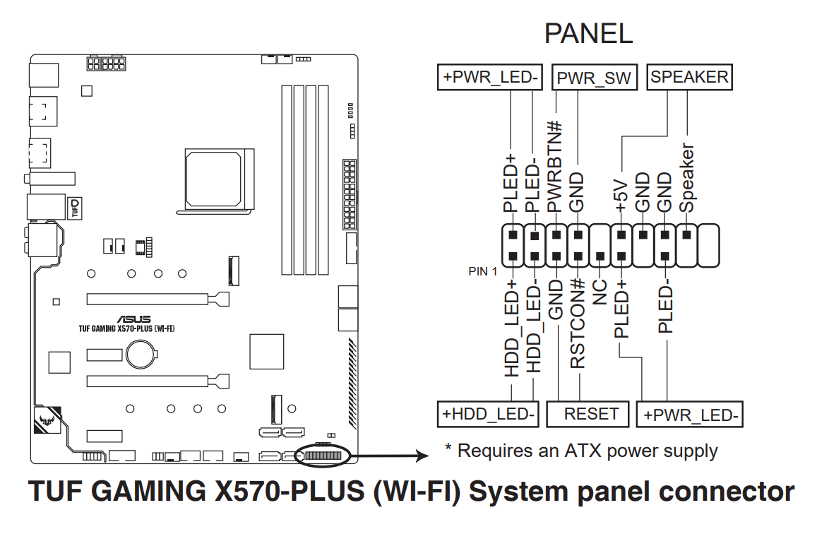

*Overall*

The purpose of this part of the computer is to allow the user to safely contain their more important parts in a case to prevent the outside elements from getting in. Dust is one of the worst elements that can harm a pc and a pc case safely ravels all the other parts to always sit in one place.

**Motherboard**

*Sizes*

Motherboards can come in three main sizes, from largest to smallest: EATX, ATX, Micro-ATX and Mini-ITX.

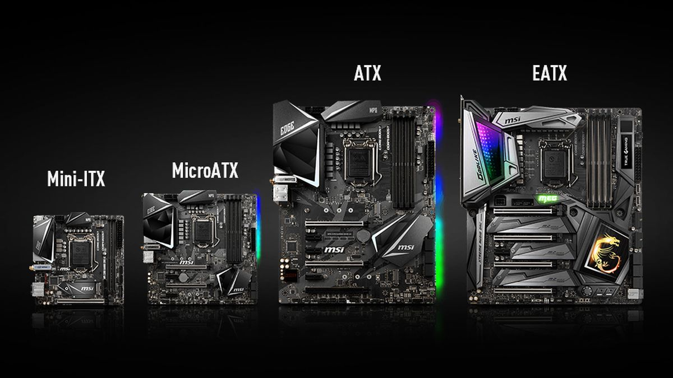

EATX or extended ATX is essentially an extended version of the ATX board, meaning it is bigger than the normal layout for all motherboards. Most if not all PC cases cannot hold a EATX motherboard due to its size. However, some cases are designed specifically for this motherboard and special builds. EATX (Extended ATX) is a bigger version of the ATX motherboard with 12 × 13 in (305 × 330 mm) dimensions.

An ATX motherboard is the most common layout for any computer on the market designed by intel in 1995. The ATX motherboard is the industry standard for all common sized motherboards. It is designed so that it will be able to fit in almost all full and mid-sized PC cases. The ATX board generally measures in at 12 inches by 9.6 inches

The Micro ATX motherboard was designed 2 years after the ATX motherboard in 1997. This board is basically the same design as the ATX motherboard but shrunken for consumers who needed a more minimalist and less clunky setup. The Micro-ATX generally measures in at 9.6 inches by 9.6 inches

The Mini-ITX is a 17 × 17 cm (6.7 × 6.7 in) motherboard form-factor. It was developed by VIA technologies in 2001 for consumers who wanted even smaller computers. It was designed to support relatively low-cost computers in cramped environments. Such as the computers that are all in one.

*Cost*

The cost of motherboards unlike the computer cases ranges heavily in price dependent on the size and performance of the board. For instance, if one board is listed to have better chip sets and better technology in general, they will differ by hundreds of dollars. The average cost for a good motherboard in the 2021 market is about 150 to 250 dollars. Of course, this price can rise dependent on the type of custom PC you are building but that price would be a good benchmark.

*Compatibility with CPU*

While we already talked about the board’s compatibility with a computer tower, we have not talked about the most important compatibility issue, which is with the CPU. Each motherboard is essentially the same dependent on the brand but there are distinct differences in what is known as the “CPU socket”. The socket I’m referring to is in the image below.

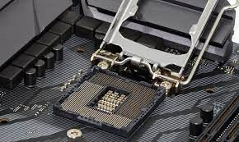

This socket has two distinct differences in which CPU can fit in the motherboard. There are two different brands that each motherboard builds toward which is either AMD or Intel. The image below are the two differences between each socket:

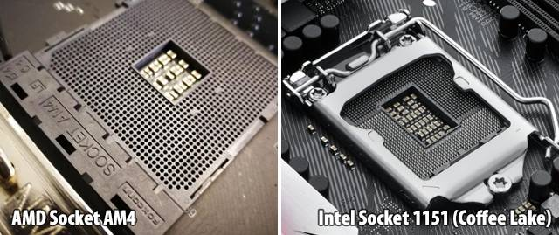

While not much visual difference each socket can only fit a certain type of processor. The difference to watch for is whether the socket contains a metal clamp or not to keep the CPU in place. Only intel processors will contain the metal bracket to keep the CPU from moving. The AMD Socket does not have this. So if you do not watch out for this key difference, some CPUs will not fit inside a motherboard.

*Installation into Case*

To put the motherboard into the pc case it is as simple as aligning the motherboard with the standoffs that are placed in the case for the board to sit.

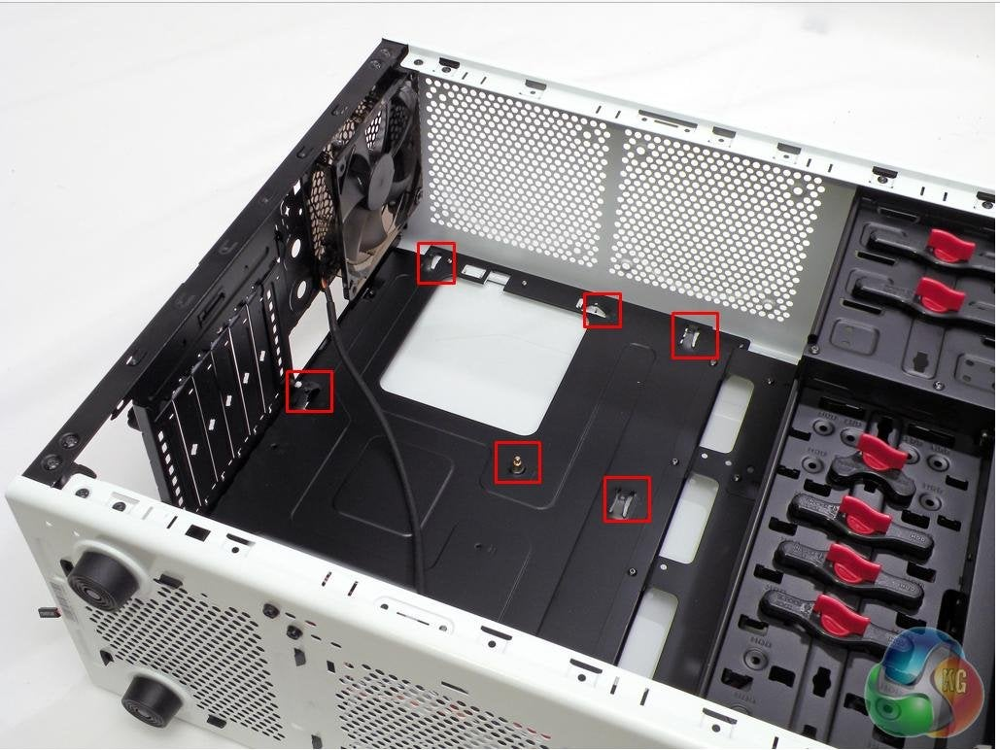

Once aligned you should have screws given with the motherboard to secure the motherboard in place. Be sure to not screw in the motherboard too tight or it will be impossible to replace later. A hand tight screw will be enough for the purpose of keeping the motherboard in place.

**Random Access Memory (RAM)**

The RAM is essentially the memory that the computer runs with. This is important to determine how many programs and files can be open at the same time. As well as how fast our computer responds to our commands. RAM is the mastermind of multitasking for a computer.

*RAM Sizes*

RAM size is one of the most important factors to pay attention to when looking to buy memory for your PC. DDR4 is essentially the industry standard for fast RAM that connects to all computers in modern day. The varieties you are most likely to find in computers are: 4GB, 8GB, 16GB, and 32GB. Most lower memory RAM from 4GB to 8GB are used solely for lower end office work machines. For instance, something you would find in your teachers’ computer. For a good gaming PC, you would find most computers containing two sticks of 16GB of RAM.

RAM like the other computer parts must link to your CPU for compatibility. These compatibilities are virtually impossible to tell from visual senses, so I would use a sight that checks for compatibility. Such as:

<https://www.kingston.com/unitedstates/us/memory>

*Cost for Size*

RAM costs are just as expensive as the motherboard and case. RAM essentially goes up by at least 100 dollars for every stage of memory. For example, a RAM with 2x16GB will total around 150 dollars and RAM that are 2x32GB would double to 300 dollars. A good RAM for gaming and productivity would also be the 2 sticks of 16GB which is 32GB. A good DDR4 RAM would allow you to do almost everything you want at a reasonable speed and should only cost around 150 dollars.

*Installation into Motherboard*

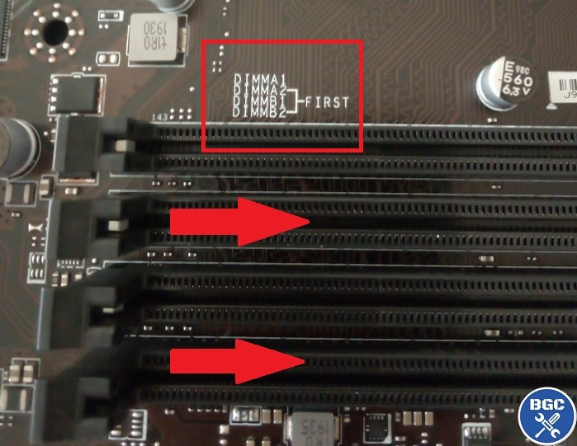To install RAM into a motherboard you simply find the slots that are designated for the ram sticks to sit in. Another important thing to look for in this process is to look at the board manual or on the board itself to see what slots get priority. Priority meaning that the slots that are marked should contain a stick of RAM first for better performance.

**Central Processing Unit (CPU)**

The CPU is one if not the most important part of the computer. Essentially what the CPU does is that it enables your computer to interact with all the applications and programs installed.

*Cost*

The cost of CPU may vary depending on how up to date the processor is. This means with every new CPU that comes out will mostly be the best performing processor and the most expensive. The prices of processors can range from $100 to as high as $800. The two competing companies that dominate the market is both AMD and Intel. Although they have very similar technology, as I mentioned before you can only have certain CPUs with certain motherboards. Some options that are of interest in today’s market include AMD Ryzen processors and Intel Core I Processors. While they are completely similar products, the performance may very depend on the companies. See this website for the best deals and different types of processors you can purchase:

<https://www.newegg.com/CPUs-Processors/Category/ID-34>

*Installation into Motherboard*

To install a CPU, you simply put it in the motherboard processor socket. Be careful during this process as you can break a pin on the bottom of the CPU without proper handling. Also, a thing to watch out for is the arrow that marks which way to place the CPU.

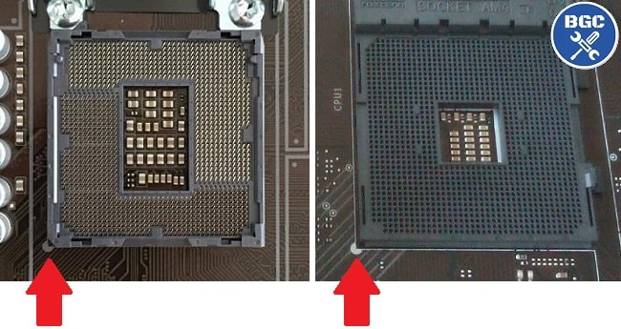

After aligning the CPU arrow with the motherboard marker, the processor should simply fall into place. If there is strain on the CPU do not force it into place as you are not placing it in the correct way and could break the processor.

As soon as the CPU is placed into the motherboard you secure it in place with the lever on the side. Pushing the lever on the side down and securing it in place will keep the CPU from moving in the future.

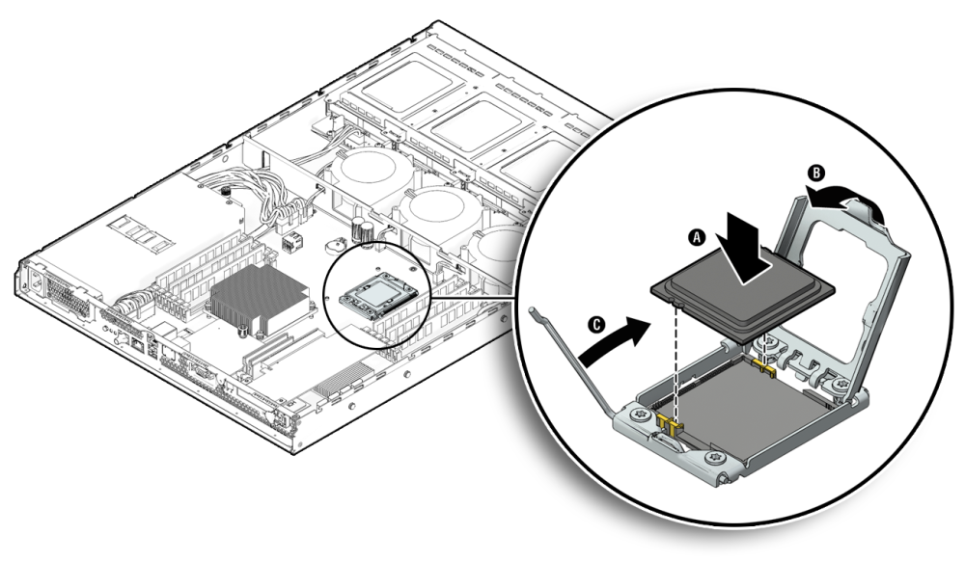

**Graphics Card (GPU)**

A graphics card or graphics processing unit is a specialized processor originally designed to accelerate graphics rendering. A graphics card can process many pieces of data simultaneously. Therefore, graphics cards are great for video editing, gaming, and streaming.

*Cost*

Graphics cards are by far the most expensive part of making a computer. Since the inflation of the graphics card market and limited availability, GPUs have essentially become the most sought after and expensive items. There are two companies that dominate the market, Nvidia and AMD. Those two companies continue to put out the best up to date technology in the world. Since the inflation of the market, resellers have been racking up the prices of almost every card. This can range from as high as $5000 to $400. You will rarely be able to find a new high end graphics card unless you wait for the stores on the release date.

*How to Connect to Motherboard*

Like RAM the installation for a graphics card is very similar. There is a designated slot for a graphics card. The top slot is usually the better option for performance. Simply place the graphics card in the slot until you hear a click sound to ensure the card is secure. Once you place it in the slot, you should also secure it to the PC case via a screw given with the case.

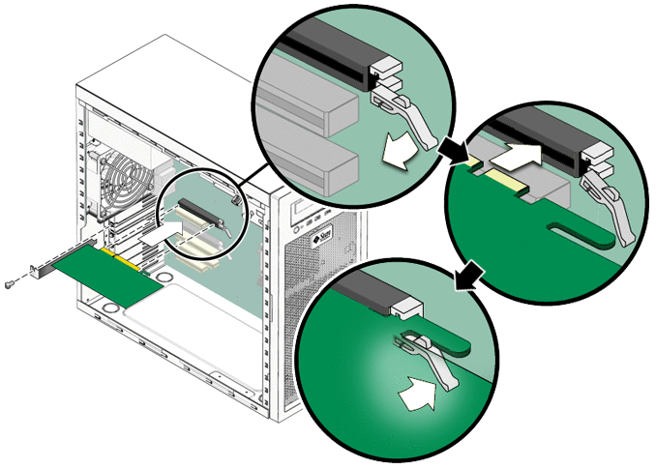

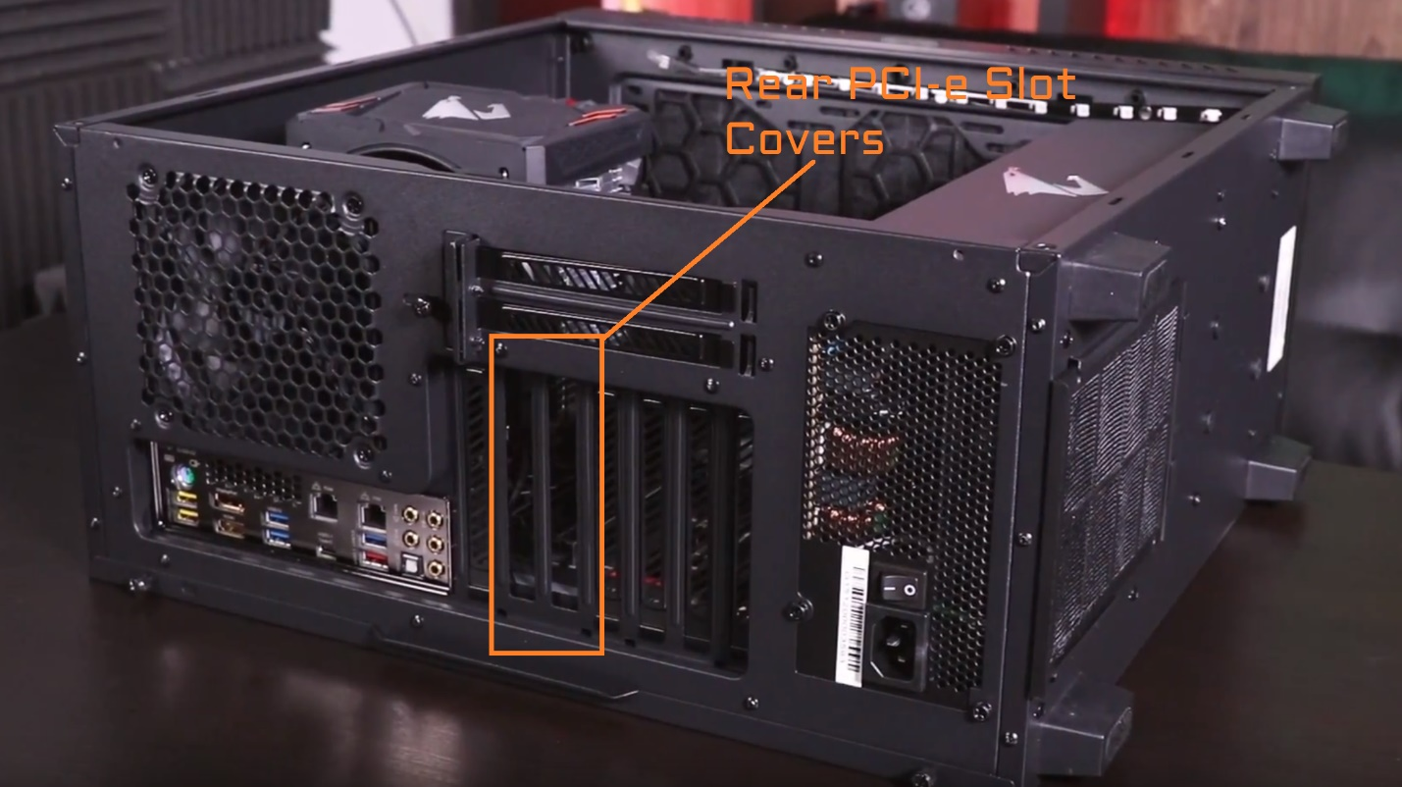

*Compatibility*

Unlike the other parts the GPU does not require specific brands to fit with a certain motherboard. You can essentially use any GPU on any computer. If the graphics card is not significantly older than the motherboard you can use it. Lower end graphics cards work with higher end systems and vice versa.

**Solid State Drives (SSD) / Hard Disk Drive (HDD)**

An SSD or HDD is essentially the storage device of a computer. This allows you to store your files, games, and videos. The SSD works alongside your system memory and processor to access and use data. The difference between a hard disk and a solid-state drive is the speed of loading memory. A solid-state drive is a faster alternative to hard disks because it is no longer a mechanical way of reading and writing data.

*Cost*

SSDs are more expensive than hard drives in terms of dollar per gigabyte. A 1TB internal 2.5-inch hard drive costs between $40 and $60. The very cheapest SSDs of the same capacity and form factor start at around $100. This directly correlates to the speed of reading and writing information in a system. It is also proven that SSDs last longer in terms of writing and deleting new data.

There is also a new SSD that was released called a M.2 drive. This is a smaller form factor SSD that basically functions the same as its larger counterpart.

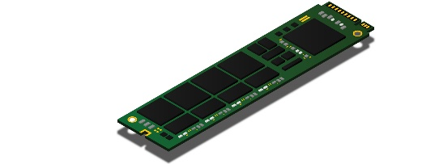

*How to Connect to Case and Motherboard*

To install a SSD or HDD you simply plug in the power cable and the sata data cable to the motherboard. The power cable will come with the power supply, however the sata cable will usually come with the drive.

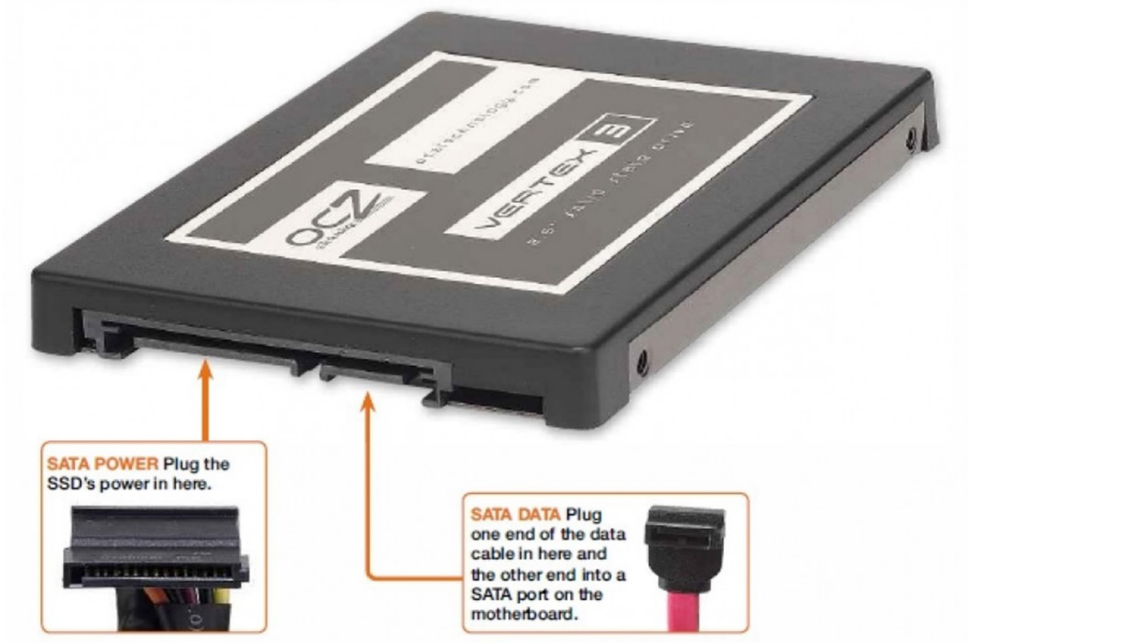

Once it is connected to the SSD you simply connect the other end of the sata cable to the motherboard and place the SSD somewhere inside the case.

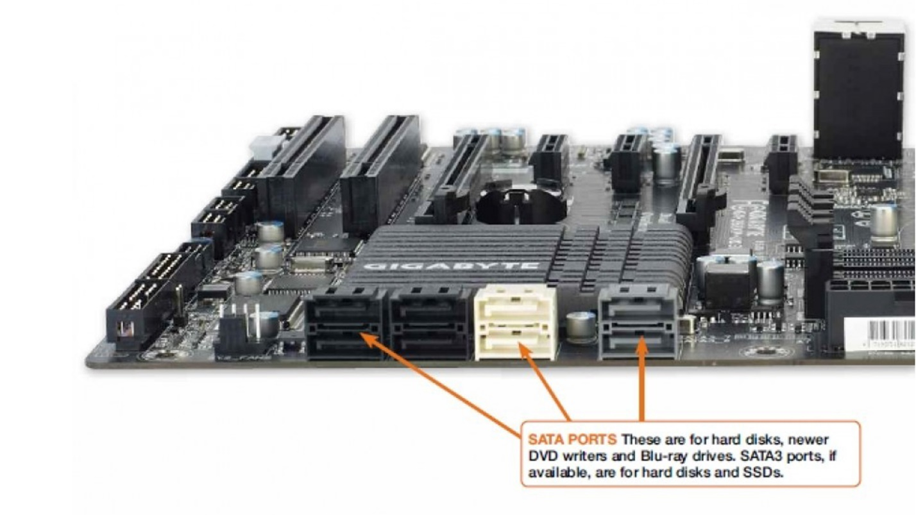

To install a M.2 drive it is a little different than the other SSD. For newer motherboards there are ports that are designed for this new drive. You simply find the port and place the drive in the port and secure it with a screw.

To ensure no damage to the drive make sure to align the pins in the correct order. Meaning that you should align the pins on the drive with the pins on the motherboard.

**Power Supply Unit (PSU)**

A power supply is used to power the entire system and all the components. It is designed to convert high voltage current into direct current that the computer can handle. Direct current is regulated by the power supply which is required for modern computing components.

*Cost*

When choosing a power supply, it is never smart to pay less for a lower grade. A power supply is important because without it you cannot power the other components. If you buy a power supply that is of lower quality, it could damage the other components in the system in the event of a complete failure. There are instances of lower quality PSUs exploding for people and frying all the other parts. The cost of power supplies rises with the amount of watts it outputs. The more watts and higher quality the more expensive the unit will be. A 500W power supply will be around $40 and a 1000W power supply will be around $200.

*Watts*

While making a computer it is important to keep track of how many watts that each part will require. By finding each components required watts you will need to find a power supply that outputs the exact number of watts or more than what the system requires. You can use this website to enter each components required watts:

<https://www.newegg.com/tools/power-supply-calculator/>

*Installation*

When you connect the power supply to each component you will need to consider whether you want a modular or non-modular power supply. A modular power supply is essentially one that allows you to choose which cables you would like to use. A non-modular supply will not allow you to choose which cables you will use. Modular PSUs are preferred due to the amount of space the extra cables in a non-modular power supply takes.

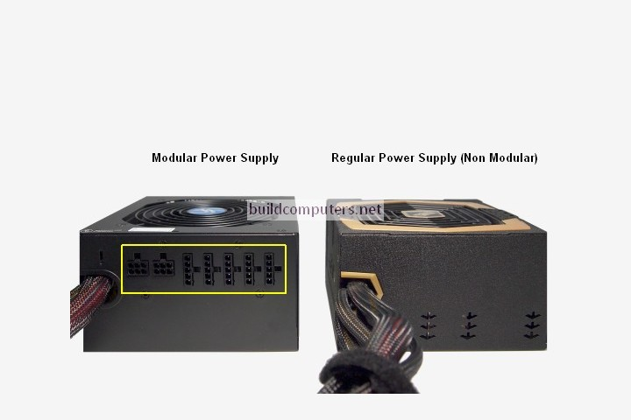

When connecting the power supply to the motherboard you will need to use two cables the 24-pin connector and the 8-pin connector. Both labeled with the following image:

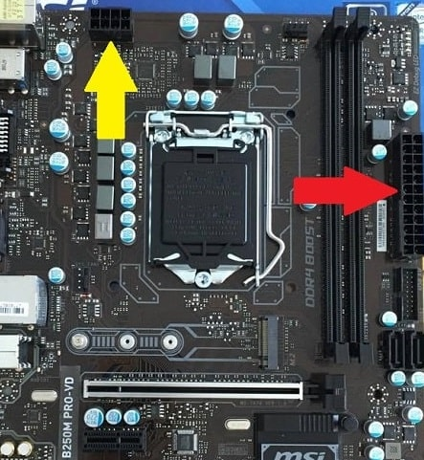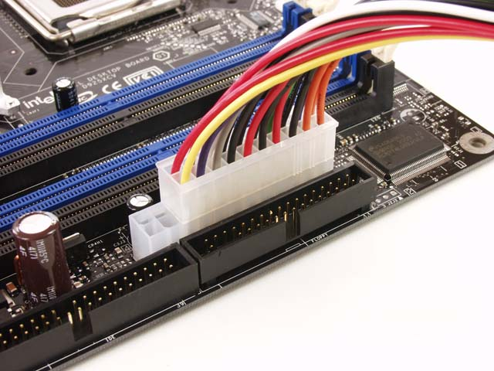

After connecting those two parts you will use the PCI-E cables to connect to the GPU. Some GPUs will only require one of these cables while some will require two. This is also dependent on how much power the GPU will require.

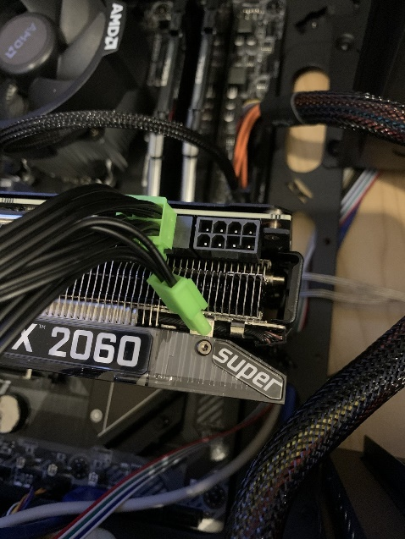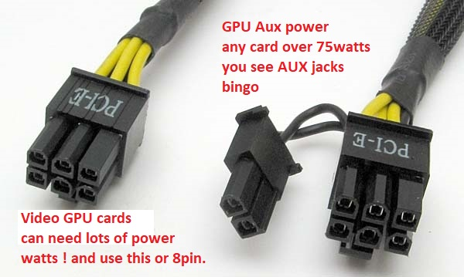

**System Cooling**

*Intake vs. Exhaust*

Cooling your system is important when dealing with all the power and electricity that each component needs. To cool a computer, you will need a set of fans that will provide air flow to all the parts. A PC needs both intake fans and exhaust fans to pump fresh air in and out of the system. Usually, a PC is set up in a way where the fans have intake in the front which is facing forward to the outward part of the case. Then the exhaust fans will be facing the inside of the computer and will essentially take the air being flowed inside the case and push it out again.

You can see intake and exhaust is based on the way the label is facing on the fan. When the label is facing forward, the air is coming towards the label and pushing out past it.

RED: Exhaust Blue: Intake

*Cost*

When considering the cost of cooling your PC you should only have to consider the amount of fans that you want and how many you can fit in your computer case. Fans are usually sold in 3 packs or individually. A pack of fans is sold mostly from $30 to $60 and individual fans are usually sold more expensive at $30 due to the brand and performance.

*Installation*

To install case fans on a PC case you would simply have to place them in the right order and use the screws provided with the fans to secure them from moving. Usually, PC cases will usually cover this step for you since they usually have fans installed already.

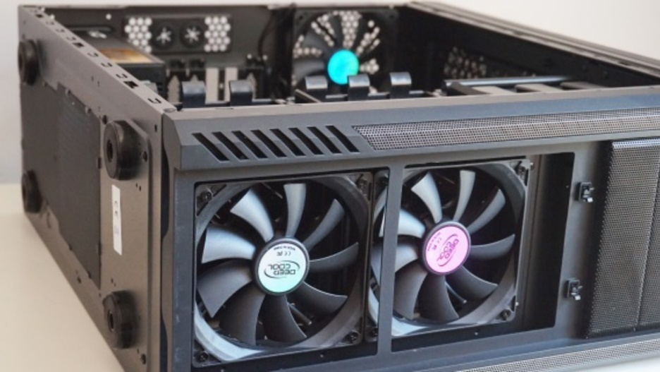

The next step after installing the fans into the case is to simply connect it to the motherboard. You will need to find the ports on the motherboard that are the labeled fan headers.

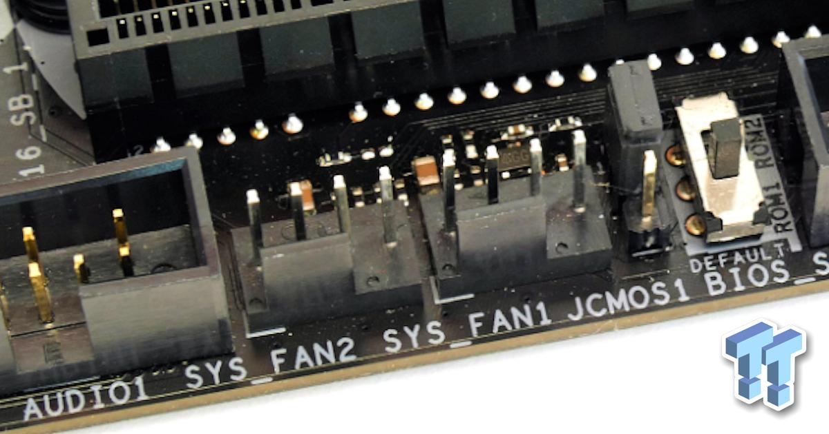

After finding these labeled headers you will need to run the cable from the fan to those ports on the motherboard.

**Peripherals**

After assembling all the internal components all that is left is to find a mouse, keyboard, and monitor.

*Keyboards*

There are two different types of keyboards in the market, membrane and mechanical. Membrane keyboards are self-explanatory meaning that they have a rubber membrane under every key. A mechanical keyboard are mechanically built switches that have their own individual parts and are activated separately.

Mechanical keyboards are generally recognized as better for gaming and overall feel when typing. This feeling can be taken to the extreme and are the reason why mechanical keyboards can be expensive. Membrane keyboards are generally used for productivity without regard for price. These types of keyboards are used in laptops and come with prebuilt computers.

Their prices vary dependent on the type meaning that mechanical keyboards can go as high as $200 and membrane keyboards usually only go for $20 or less.

*Mouse*

To navigate around on a monitor when using your PC, you are going to need a mouse that will allow you to do so. The major differences between mice are that there are expensive gaming mice and cheap productivity mice. Gaming mice are expensive due the technology of the sensor needed for gaming at a high and accurate level. These can max out around $200 dollars due to professional gamers need for the best sensors. Lower end mice can go as low as $10 or less because of their intended use. They are generally only used for productivity purposes so there is no need for the expensive sensors.

*Monitor*

Finally, what you will need to see if your system is working is the monitor. The monitor is used as a display of graphics from your PC. To connect the monitor to your PC, you will use one of the cables they provided for you and connect it directly to the graphics card. One of the things to watch out while plugging in one of the cables is to not plug directly into motherboard. Meaning that you should not use the onboard graphics as it might perform less than if you would plug directly into the graphics card.

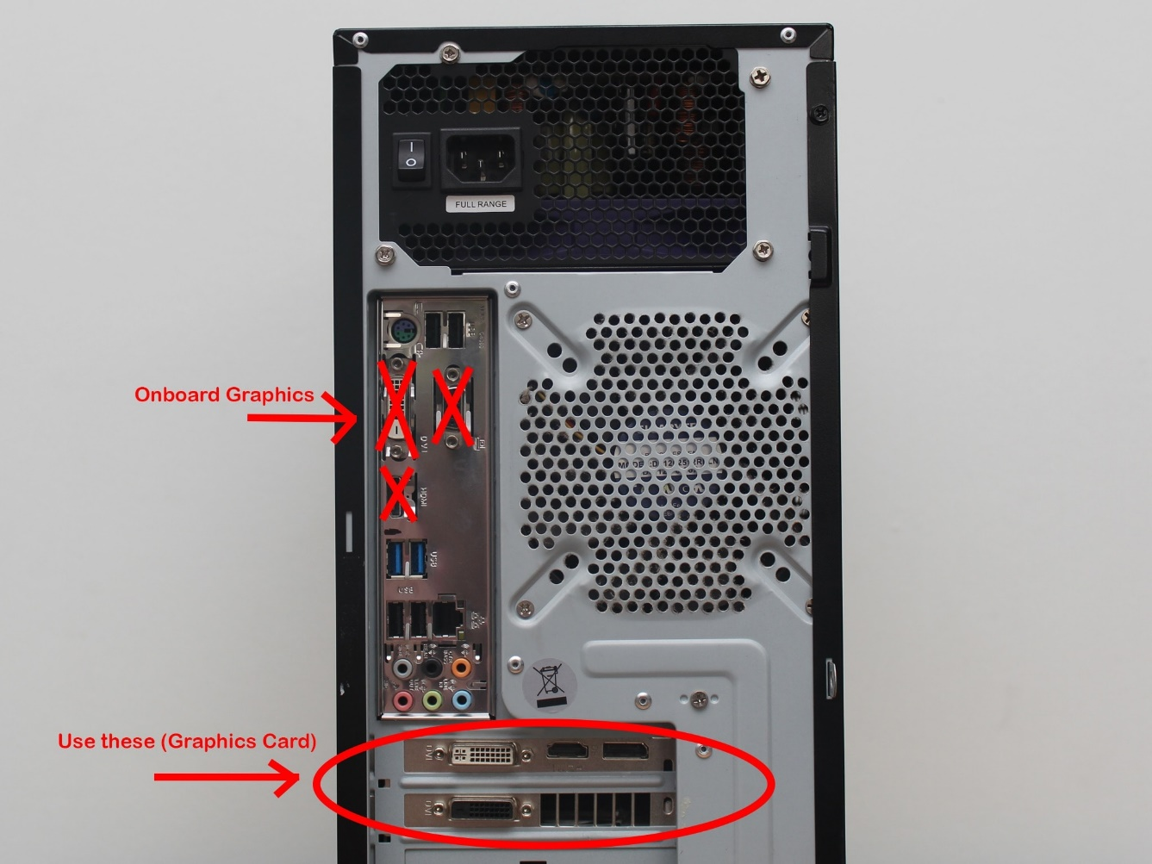

You could run into many different types of cables when encountering this step. There is a display port cable, HDMI cable, or a VGA cable. All ports do the same thing, but the best performing cord will be the display port cable. When deciding which port to use you should proceed in this order: display port, HDMI, and VGA.

**Overall**

After following all these steps and nuances, you should be done building your PC. Make sure all the components are running including all the fans and be sure to clean the inside of the computer from time to time. If anything is not running it could cause some serious problems down the line. If it does not turn on, make sure all the correct cables are plugged in and always stay clear of components when power is running through the system. Kill the power and inspect where the entire PC before turning it back on again. If you want to clean your PC, you can use an air duster that will get rid of all the dust hidden inside the components. Overtime dust can cause your PC to run hotter and slower due to build up. Eventually it could cause the PC to short circuit so make sure to clean it at least once a month.

**Sources**

Safford, Matt. “How to Buy A Motherboard: A Guide for 2021.” *Tom's Hardware*, Tom's Hardware, 28 Jan. 2021, https://www.tomshardware.com/reviews/motherboard-buying-guide,5682.html#:~:text=Motherboards%20come%20in%20three%20main,RAM%20slots%20and%20other%20connectors.

*Pick Parts. Build Your PC. Compare and Share. - Pcpartpicker*. https://pcpartpicker.com/.

“Custom PC Builder: Newegg.” *Newegg.com - Computer Parts, Laptops, Electronics, HDTVs, Digital Cameras and More!*, https://www.newegg.com/tools/custom-pc-builder.

“What Memory Is Compatible with My Desktop PC, Laptop or Server? - Kingston Memory Finder - Compatible DRAM - Kingston Technology.” *Kingston Technology Company*, https://www.kingston.com/unitedstates/us/memory.

“How to Find Compatible Motherboards for Your Intel® Boxed Desktop...” *Intel*, https://www.intel.com/content/www/us/en/support/articles/000005909/processors/intel-core-processors.html.

“Computer Ram.” *Computer Hardware Explained*, https://www.computer-hardware-explained.com/computer-ram.html.

Brant, Tom. “SSD vs. HDD: What's the Difference?” *PCMAG*, PCMag, 2 Sept. 2020, https://www.pcmag.com/news/ssd-vs-hdd-whats-the-difference.